Information about the equipment produced at the Open Joint Stock Company «Gomelagrokomplekt».

Herringbone and Rapid-exit Herringbone milking plants are the most popular types of milking parlors with free-stall housing of cows:
- good ergonomics of service personnel work;
- high performance;
- possibility of equipping with automation systems, including measurement of milk flow parameters and cow identification, as well as activity and rumination monitoring;
- increased operator productivity, faster and more efficient milking of cows.

Features and characteristics of Herringbone milking plants
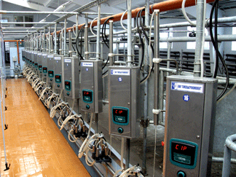
This type of milking plants is designed for machine milking on a special milking platform in the parlors with free-stall housing of cows. The milking plants assure high throughput per hour, while the milking parlor management software enables the operator to keep the record of milk yield per each cow, systematize physiological changes in the cow condition, perform calculations on a case-by-case basis, perform certification of cows. All milking parlor control system units are operated from one PC (included into the delivery set). The stalls for cows are arranged at an angle of 30° with respect to the milking trench.
The milking parlor equipment has a robust design and has no sharp angles to protect the cows from injuries. The steel structures have a hot-dip galvanized coating that provides for long-term operation in an aggressive environment. A safety board protects the milker and the cow against accidents. Reliable ladders to get down into the milking trench provide additional convenience during operation and cleaning of the milking parlor. Pneumatic entrance gate, entry and exit gates are controlled from the technological trench.

Quick-entry Herringbone milking plant
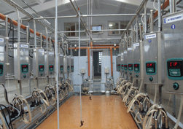
Milking plants are intended for machine milking of cows on a special platform in the stalls arranged pairwise at an angle of 30° with respect to the technological pit. Simultaneous opening of the front fences (with the aid of a mechanical drive) is envisaged which provides for a rapid exit of animals out of the milking stalls.
The plants are produced in two modifications:
- without automatic computer control of the milking process – UDA;
- with automatic computer control of the milking process – UDM.
Milking plants are equipped with a computer herd management system that is designed for automated operational control over the cattle herd at dairy farms. It provides for collecting and processing the data on each cow and enables the farmers to manage the processes of cows regrouping and herd reproduction, and automatize the following tasks:
- cows separation from the herd at the operator's command;
- accounting, planning and control of milk production;
- accounting, planning and control of calving, inseminations and pregnancy testing;
- analysis of the structure and physiological condition of a herd;
- registration of the animals admission and withdrawal.
- cow heat time detection;
- rumination determination (health monitoring).
Parallel milking plants assure high throughput owing to simultaneous exit (all cows on one side can leave the row at the same time after the front cage has been lowered) and the next group of cows may enter the milking points. Milking plants are intended for machine milking of cows on a special platform in the stalls arranged pairwise at an angle of 90° with respect to the technological pit. The plants are produced in two modifications:
- without automatic computer control of the milking process – UDA;
- with automatic computer control of the milking process – UDM.

Parallel milking plant
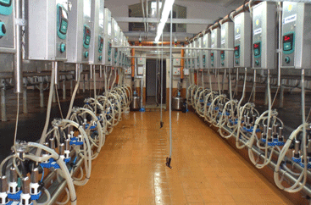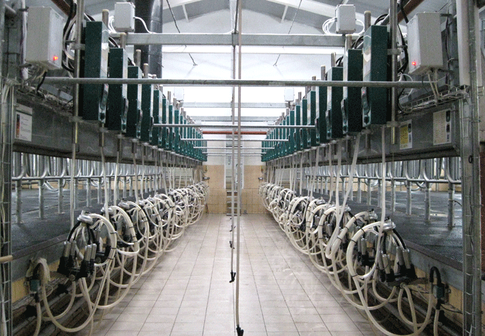
The plant is equipped with advanced modules to exercise milking control at the milking post. The system has many new advanced functions: display with indications of milk yield and milk flow intensity; upgraded programs of pulsation with automatic stimulation of the udder; pulsation controlled by milk flow; automatic detachment of a milking unit at the end of milking; warning on dropping of a milking unit or low milk yield; remote programming; simple operations of the control button, etc. The control module can be configured to fit almost any requirement of the user. The cow identification is exercised by a transponder – an upgraded sensor-collar, which allows (along with the identification of a cow) to determine its heat time and activity of chewing process. The herd management system "DataFlow" is used for integrated management of a herd and the process of milking, which includes a number of electronic modules and Windows-based software.
Depending on the number of cows milked at the same time and based on the needs of the customer, Herringbone and Parallel milking plants may have different combinations: from 2x6 to 2x24 (number of milking plants), number of milked cows - from 200 to 1100.

Milking plants with a milk line.
Machine milking plants for stall housing are available in configurations for 100 and 200 cows. Milking Plants ADSN (100 cows, milking is exercised into a stainless steel milk line Ø52 mm);
Milking Plants 2ADSN (200 cows, milking is exercised into a stainless steel milk line Ø52 mm);
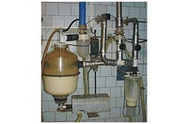
Milking plant PDU-8/ PDU-8М (milking is exercised into a bucket or milk line in the pasture or in a camp; vacuum station is driven by PTO shaft of the tractor, electric motor or a small combustion engine);
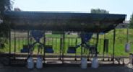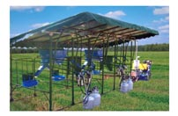
The above mentioned milking plants may be equipped with the following types of milking units (if requested by the customer):
- milking unit for pairwise milking ADS 25.00.000 (for milking into a milk line or a bucket; with pulsator);
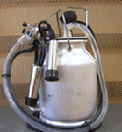
- milking unit for pairwise milking "SOZH" ADS 24.00.000 (for milking into a milk line or a bucket; with pulsator, manifold with increased volume (350 ml), gentle milking mode, double vacuum principle);
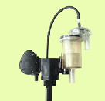
- Water-ring stations (capacity - 60, 120 l/min) are used in ADSN and 2ADSN units.
- Oil vacuum station with capacity of 1000, 1500, 2100, 3100 l/min is used to create vacuum in Herringbone and Parallel plants. Besides, the station is equipped with the rpm frequency regulator which allows to control the vacuum level using an electronic sensor.
- Plants for milking into the milk line are equipped with a modern electronic device for milk batch accounting UPUM-01 designed to keep the record of milk yield from 4 groups of cows with separate accounting and possibility of summation of indicators and devices for zootechnic milk control MM-04V for milking control.
- The design meets the highest hygiene requirements.
- Stable level of vacuum
- Long service life
- All nodes are adapted to the existing Russian analogues of the plants
- Reasonable prices

Milk Cooling Tank ZUOM оf open and closed type, vertical and horizontal design.
Equipment for milk cooling and temporary storage with heat recovery is designed for milk cooling and its temporary storage with simultaneous heating of water for technological needs in accumulation tanks. Direct cooling systems contain a cooling unit that supplies cooling agent which removes heat from the milk located in the milk cooler of the corresponding volume.

Milk Cooling Tank
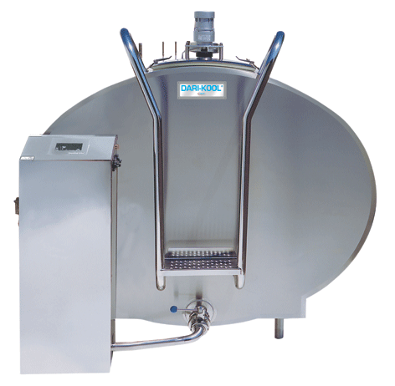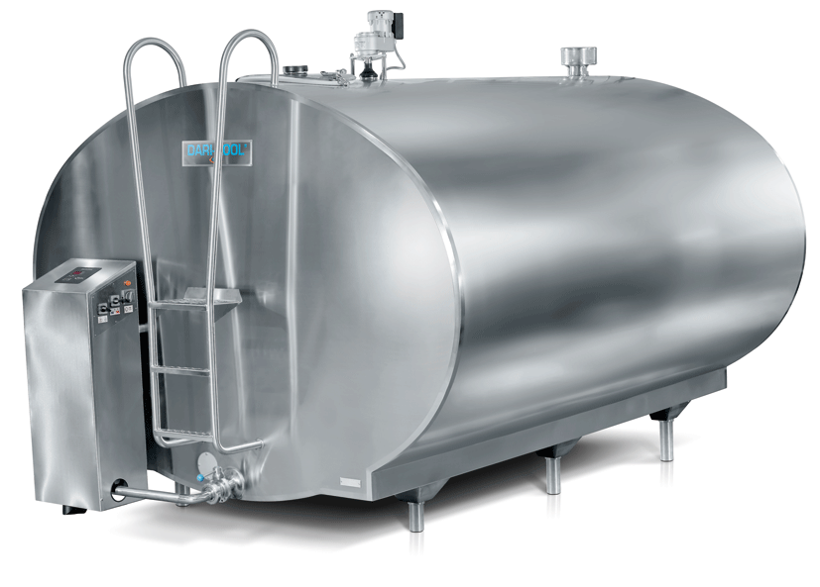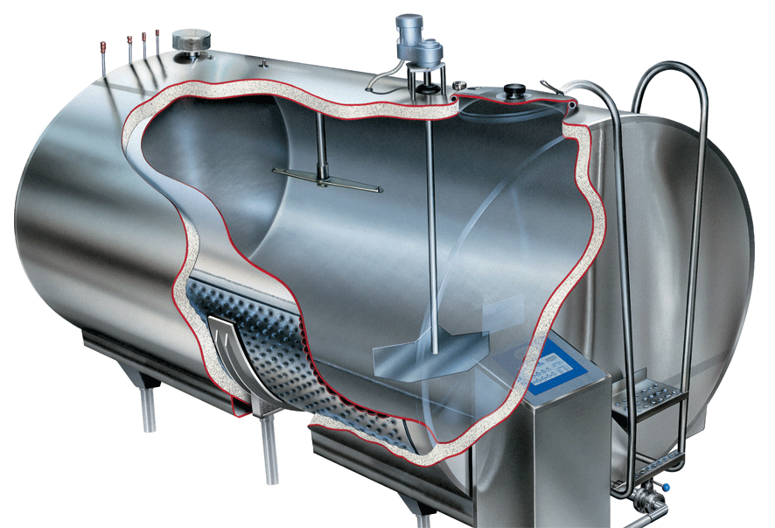

Milk cooling tank is a food-grade stainless steel vessel with an evaporator inside. The equipment provides for cooling of the milk after milking to a temperature below +4°C, its storage at this temperature, as well as automatic washing of the milk container after milk has been discharged.
Produced modifications - ZUOM-1000; ZUOM-1600; ZUOM-2000; ZUOM-3000; ZUOM-5000; ZUOM-6000; ZUOM-8000; ZUOM-10000 and higher.

Besides, JSC "Gomelagrokomplekt" produces a wide range of stall and soil-cultivating equipment.
We look forward to establish mutually beneficial and fruitful cooperation and are ready to provide more detailed information ((www.gomelagro.com, E-mail: gac@gomelagro.com, Tel.+375 232 94-15-23).
).

