Product description/name | Package/ weight | Expiry date | Price €/per MT, FCA
FLOUR EXTRUSION wheaten of first grade | Polypropylene bags (with the polyethylene insert)  15 - 25 kg | 24 months | 0,29
Potatoes starch,  Best quality | Paper strong bags  25kg | 24 months | 0,78
Starch-containing modified potatoes reagent | Polypropylene bags (with the polyethylene insert)  15 - 25 kg | 24 months | 0,82
Starch-containing modified maize reagent | Polypropylene bags (with the polyethylene insert)  15 - 25 kg | 24 months | 0,57
Extrusion potatoes starch | Polypropylene bags (with the polyethylene insert)  15 - 25 kg | 24 months | 0,82
Extrusion maize starch | Polypropylene bags (with the polyethylene insert)  15 - 25 kg | 24 months | 0,57

Product description/name | Package. weight/volume | Expiry date | Price €/per MT, FCA | Photo
Vodka "Серебряный родник",  Vodka "Охота",  Vodka "Рыбалка", Vodka "Поречьская застольная" | glass bottle  0,5 liter | Unlimited | 0,38 | 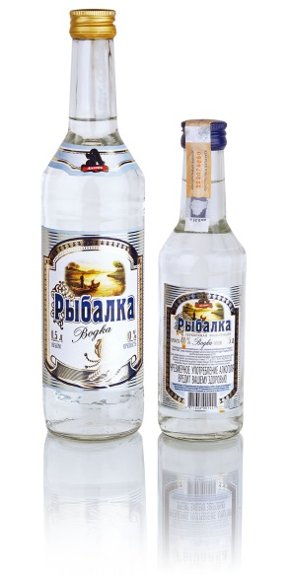
Vodka "Серебряный родник",  Vodka "Охота", Vodka «Панская охота»  Vodka "Рыбалка", Vodka "Поречьская застольная",  Vodka «Патриот» | glass bottle  0,5 liter | Unlimited | 0,43 | 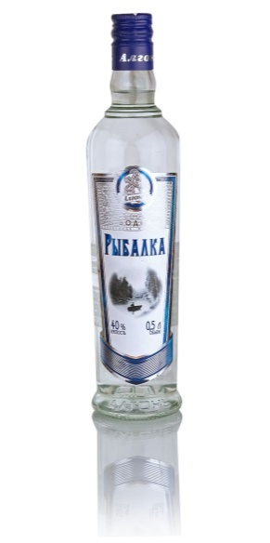
Vodka "Поречьская застольная" | glass bottle  1 liter | Unlimited | 1,07 | 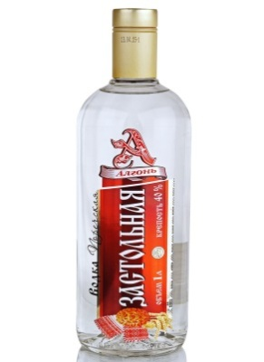
Vodka "Серебряный родник" | glass bottle  1 liter | Unlimited | 1,07 | 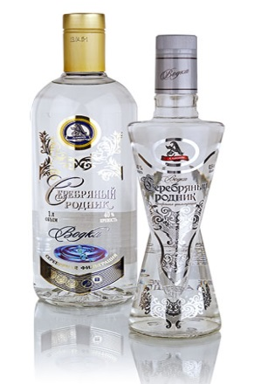
Vodka "Серебряный родник" | glass bottle  0,5 liter | Unlimited | 0,89 | 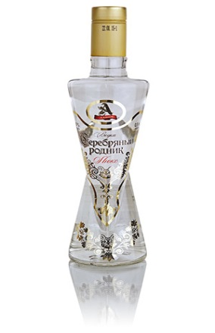
Fruit wine «Яблочный восторг», «Мадерный Бриз», «Купеческое», «Порто Биянко», «Фрутвейн Люкс» | glass bottle  0,5/0,7 liter | 12 months | 0,37/0,41 | 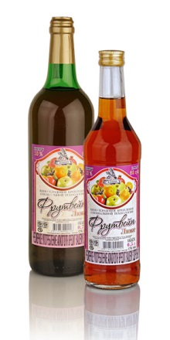

Product description/name | Package. weight/volume | Expiry date | Price €/per MT, FCA | Photo
Birch juice with sugar | glass bottle «twist-off», glass jar  0,33 л, 0,75 л, 3 л | 2 years | 0,28  0,53  1,49 | 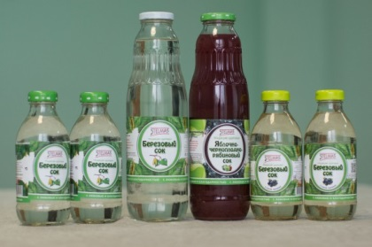
Birch apple juice with sugar | glass jar 3 л | 2 years | 1,89 | 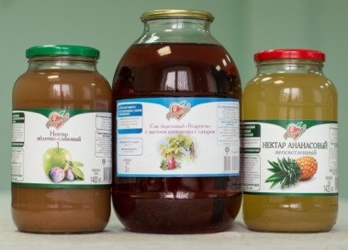
Birch juice with sugar "Bodrost" | glass jar 3 л | 2 years | 1,57
Carrot apple nectar with pulp | glass bottle «twist-off» 0,73 л | 2 years | 0,7 | 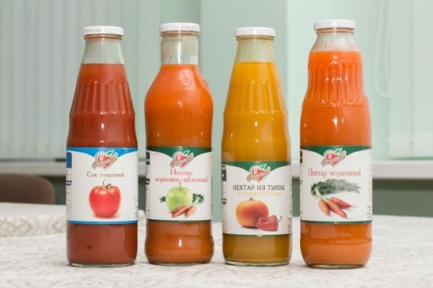
Apple nectar with pulp | glass jar 3 л | 2 years | 1,87
Canned green peas top grade | glass jar «twist-off» 0,45 л | 2 years | 0,53 | 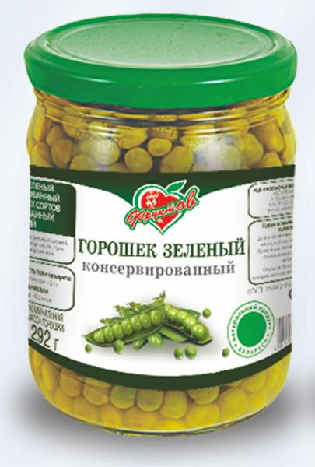
Rassolnik | glass jar «twist-off» 0,46 л | 2 years | 0,66
Saltwort from sauerkraut | glass jar 0,51 л | 3 years | 0,85 | 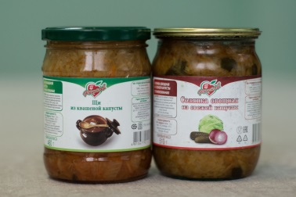
Saltwort from fresh cabbage | glass jar 0,51 л | 3 years | 0,78
Pickled cucumbers "Classic" | glass jar «twist-off» 1,5 л | 3 years | 1,92 | 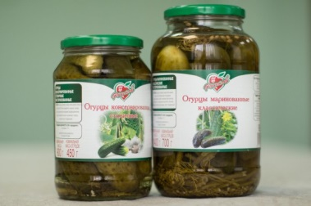
Pickled tomatoes "Pachastunak" | glass jar 3 л | 3 years | 1,98

